
PROJECT IMPLEMENTATION DOCUMENTATION
Secure Deployment of a Flask Web Application on AWS
Student Name: ________Joyal Wilson____________________________________
Batch / Cohort: _______Computer Science_____________________________________
AWS Console Username / Account ID: ____________________________________________
Resource Naming Prefix Used (e.g. gopu-): _student___________________________________________
Project Duration: _________4hrs___________________________________
Repository (Fork) URL: ____________________________________________
Final Deployed Application URL: ___________________http://3.25.108.120.5000_______________________
Submission Date: ________10 October 2026____________________________________
Note: every screenshot in this document must show the AWS Console top-right corner (your username/account ID) and a resource name carrying your naming prefix above.

Table of Contents
Table of Contents 1
1. Abstract 1
1.1 Identity Verification 1
2. Objectives 1
3. Tools & Technologies Used 1
4. Architecture & Design 1
4.1 Design Decisions 1
5. Implementation Walkthrough 1
5.1 Networking Setup 1
5.2 Security Group Configuration 1
5.3 IAM Role Setup 1
5.4 S3 Bucket Configuration 1
5.5 RDS Database Setup 1
5.6 EC2 & Application Deployment 1
6. Testing & Validation 1
7. Challenges Faced & Solutions 1
8. Conclusion 1
9. References 1

1. Abstract
Write a 4–6 sentence summary of what you built, which AWS services you used, and the key security principle the project demonstrates (network isolation and identity-based access instead of shared secrets).
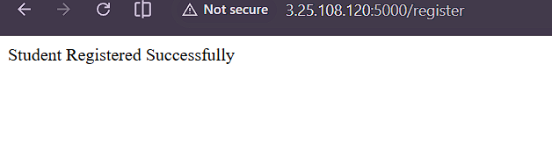
This project focuses on the secure deployment of a Flask web application on Amazon Web Services (AWS). The application allows users to register student details and upload student photos. Amazon EC2 is used to host the Flask application, Amazon RDS MySQL is used to store student information, and Amazon S3 is used to store uploaded photos.

The project includes configuring a Virtual Private Cloud (VPC), subnets, security groups, and an IAM role to manage access between AWS services. The database is configured for private access, while the S3 bucket blocks public access to protect stored files. The application was tested by successfully registering a student, storing the details in the database, and uploading a photo to S3.

This project demonstrates how AWS services can be integrated to deploy a web application with secure storage, database connectivity, and access control.

1.1 Identity Verification
Capture one screenshot of the AWS Console top-right corner showing your IAM username / account ID. This establishes that every following screenshot belongs to your own AWS account.
[ Paste screenshot here: AW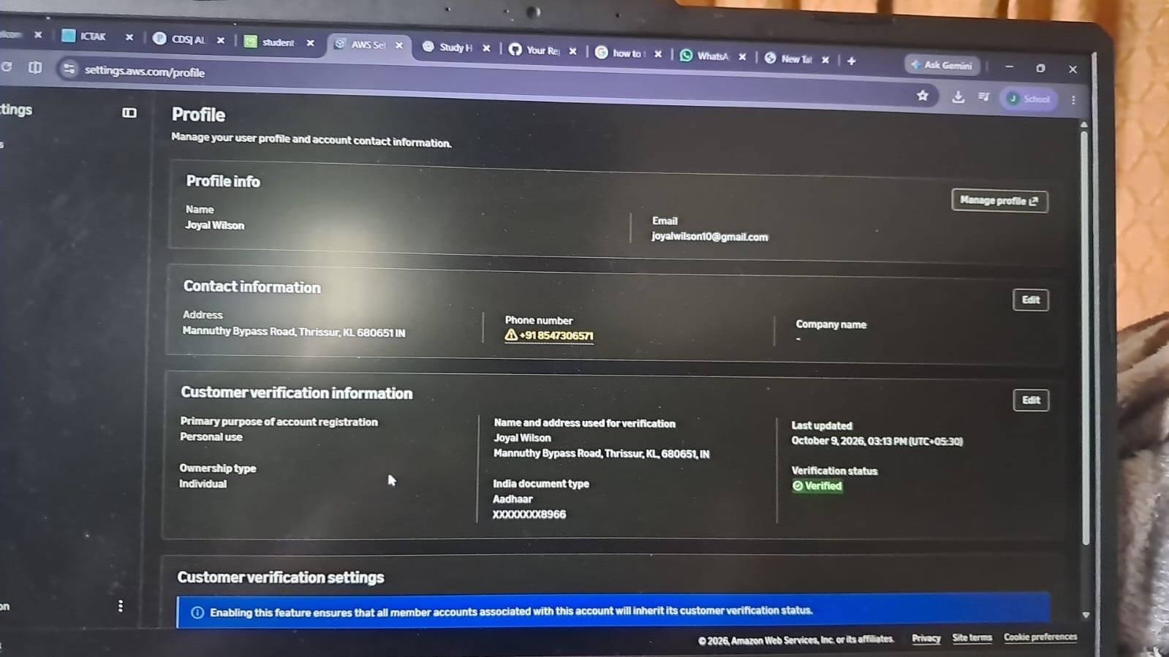S Console top-right corner — your IAM username / Account ID ]
Caption / notes: _______________________________________________________________

2. Objectives
- State the objectives of the project in your own words (3–5 bullet points).
- 1. To deploy a Flask web application on Amazon EC2.
- 2. To configure an Amazon RDS MySQL database to store student registration details securely.
- 3. To use Amazon S3 for storing student photos.
- 4. To create and configure a Virtual Private Cloud (VPC), subnets, route tables, and security groups.
- 5. To use AWS IAM roles and policies to control access between AWS services.
- 6. To restrict public access to the database and S3 bucket to improve security.
- 7. To test the application by registering student details, uploading a photo, and verifying the stored data.

3. Tools & Technologies Used
Category | Tool / Service
Cloud Provider | Amazon Web Services (AWS)
Compute | Amazon EC2
Database | Amazon RDS (MySQL)
Storage | Amazon S3
Identity & Access | IAM Roles & Policies
Networking | VPC, Subnets, Route Tables, Security Groups, Internet Gateway
Application | Python, Flask, Gunicorn
Version Control | Git / GitHub

4. Architecture & Design
Insert your final architecture diagram (hand-drawn, draw.io export, or annotated console screenshot):
[ PasARCHITECTURE AND DESIGN

### 1. System Architecture

The system follows a three-tier architecture consisting of the presentation layer, application layer, and data storage layer.

- *Presentation Layer:* The web interface allows users to enter student details and submit a registration form using a web browser.
- *Application Layer:* The Flask application runs on an Amazon EC2 instance and processes registration requests.
- *Database Layer:* Amazon RDS for MySQL stores student details such as name, email, course, and photo URL.
- *File Storage:* Amazon S3 stores uploaded student photos.

### 2. AWS Network Design

Amazon VPC provides an isolated virtual network for the project. Public and private subnets are configured to separate resources. An Internet Gateway provides internet connectivity to resources in the public subnets. Security groups control network traffic between the application and database.

### 3. Security Design

- The S3 bucket has Block Public Access enabled.
- An IAM role grants the EC2 application the required permissions to access student photos in S3.
- The database security group allows MySQL traffic from the application security group.
- SSH access is restricted using security group rules.
- Database credentials are supplied through environment variables rather than being written directly into application code.

### 4. Data Flow

1. The user opens the Flask application in a web browser.
2. The user enters student details and submits the registration form.
3. The Flask application processes the submitted information.
4. The student photo is uploaded to Amazon S3.
5. The student details and photo URL are stored in the MySQL database on Amazon RDS.
6. The application displays a registration success message.

Use the diagram above as a reference for your report. If you insert it, use this caption:

Figure 2: System Architecture of the Student Registration Application on AWS

]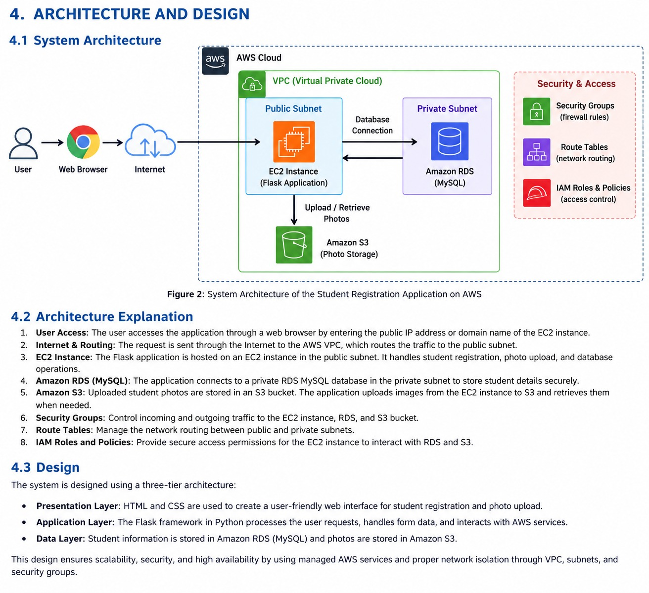
Caption / notes: _______________________________________________________________

4.1 Design Decisions
Explain the reasoning behind key design choices:
- Why the database was placed in a private subnet rather than public.
- Why the security group rules reference each other instead of using open CIDR ranges.
- Which S3 public-access option you chose (scoped bucket policy vs. pre-signed URLs) and why.

5. Implementation Walkthrough
Document what you actually did, phase by phase. Screenshots go with each phase — this section should read like a build log a colleague could follow to reproduce your setup.

5.1 Networking Setup
Summarize the VPC/subnet/route table configuration you implemented.
Networking Setup

The networking environment was configured using Amazon Virtual Private Cloud (VPC) to provide an isolated network for the Flask student registration application.

*1. VPC Configuration*

A VPC named projectvpc was created with the CIDR block 10.0.0.0/16. It provides the network environment for the AWS resources used in the project.

*2. Subnet Configuration*

Four subnets were configured within the VPC:

- Two public subnets for resources that require internet connectivity.
- Two private subnets for resources that should not be directly accessible from the internet.

*3. Internet Gateway*

An Internet Gateway named project-igw was attached to the VPC to enable internet connectivity for resources in the public subnet, according to the configured routes.

*4. Route Table Configuration*

A public route table was configured with a route to 0.0.0.0/0 through the Internet Gateway. This allows internet-bound traffic from appropriately configured public-subnet resources.

*5. Security Group Configuration*

Security groups were configured to control network traffic:

- *HTTP (Port 80):* Allows web traffic.
- *SSH (Port 22):* Restricts remote server access to the permitted client IP address.
- *Flask (Port 5000):* Allows testing access from the permitted client IP address.
- *MySQL (Port 3306):* Allows database connections from the application security group.

*6. Network Security*

The RDS database is intended to remain in private subnets and should not be directly exposed to the public internet. Network access is controlled through route tables and security group rules.

This networking setup separates resources, supports communication between the Flask application and database, and helps reduce unauthorized network access. [ Paste screenshot here: VPC and subnet configuration ] 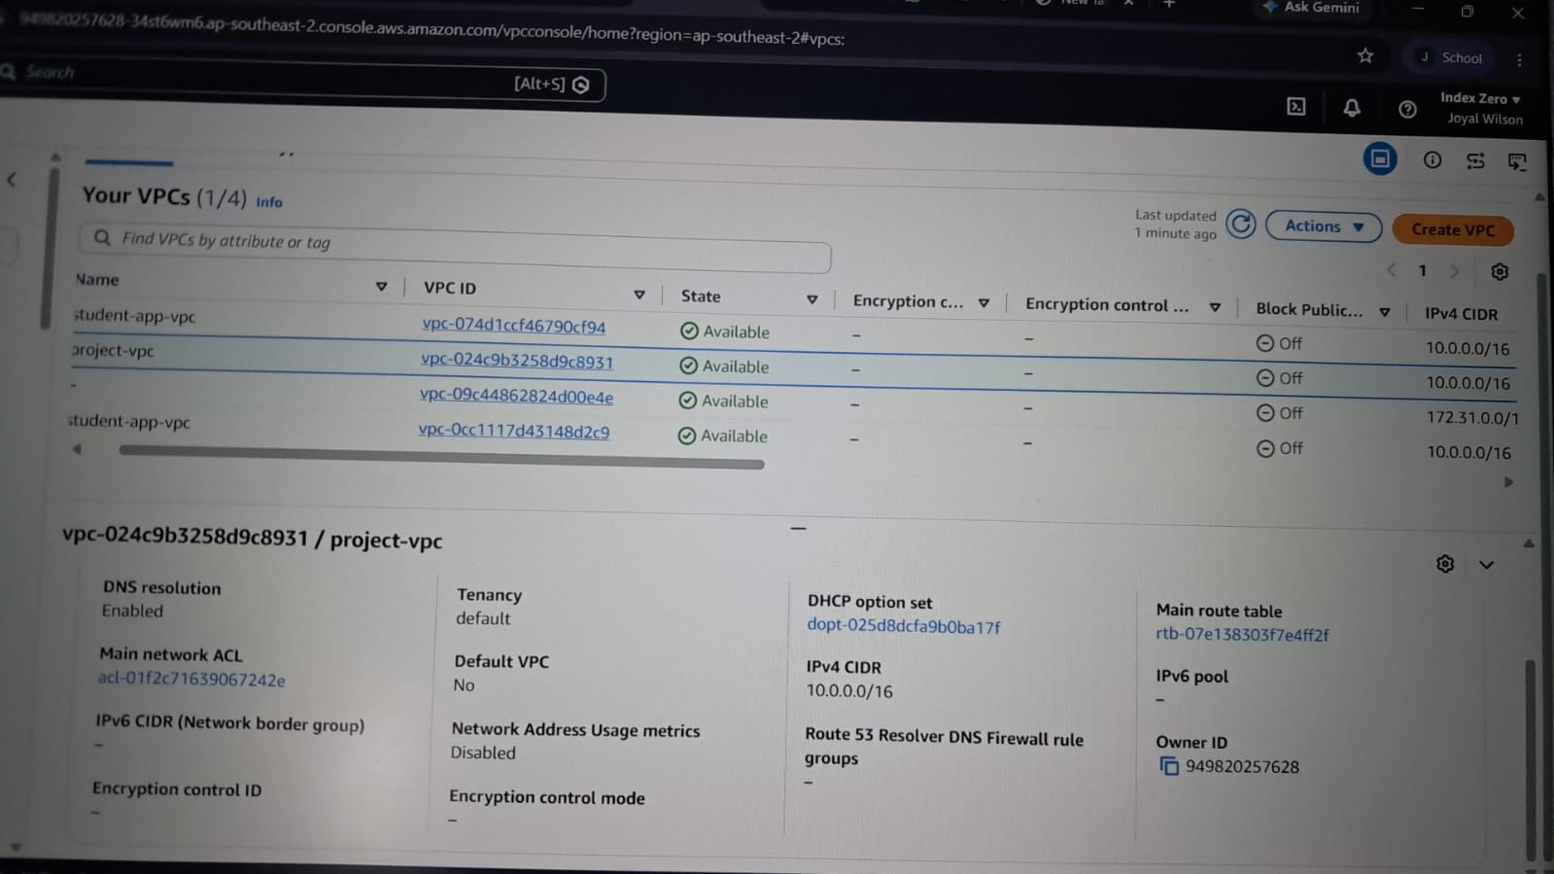
Caption / notes: _______________________________________________________________

5.2 Security Group Configuration
Summarize the inbound/outbound rules you configured for web-sg and db-sg.
[ Paste screenshSecurity Group Configuration

Security groups were configured in AWS to act as virtual firewalls that control incoming network traffic to the EC2 instance and the RDS database.

*EC2 Security Group (web-sg)*

The following inbound rules were configured:

| Protocol | Port | Purpose |
|---|---:|---|
| SSH | 22 | Remote access to the EC2 instance |
| HTTP | 80 | Web traffic |
| Custom TCP | 5000 | Access to the Flask application for testing |

SSH and Flask testing access were restricted to the permitted client IP address.

*RDS Security Group (db-sg)*

A security group named db-sg was configured to allow MySQL connections on port 3306 from the EC2 application security group (web-sg). This allows the Flask application to communicate with the database without allowing unrestricted MySQL access from the internet.

*Security Measures*

- Only required ports were opened.
- SSH access was restricted to the permitted client IP address.
- Database access was limited to the application security group.
- The security group rules help reduce unauthorized access to AWS resources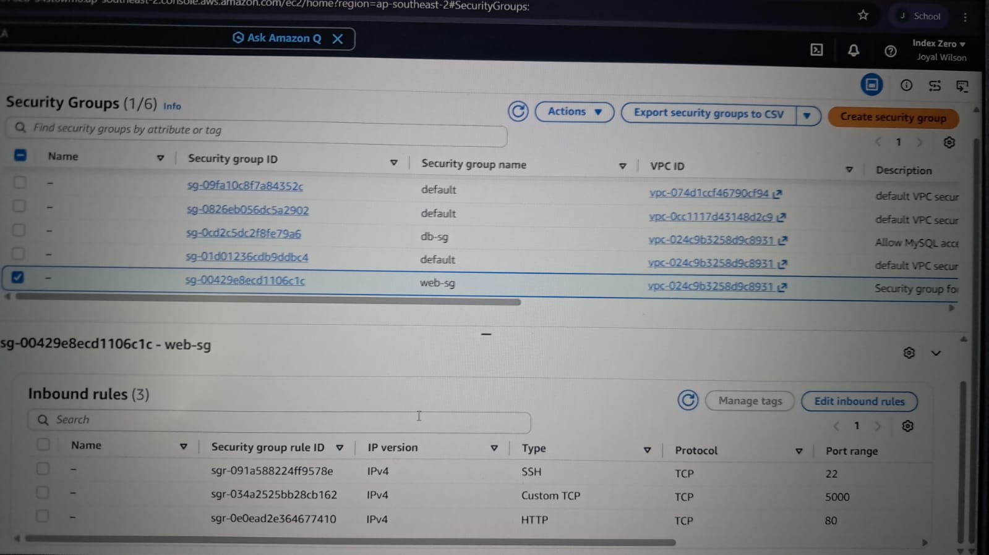.ot here: Security group rules ]
Caption / notes: _______________________________________________________________

5.3 IAM Role Setup
Summarize the IAM policy and role you created for EC2 → S3 access.
[ Paste screenshot here: IAM role a5.2 IAM Role Setup

AWS Identity and Access Management (IAM) was used to provide the EC2 instance with controlled access to Amazon S3. An IAM role was created and attached to the EC2 instance so that the Flask application could upload and retrieve student photos without storing AWS access keys in the application code.

### 1. IAM Role Creation

An IAM role named ec2-s3-role was created for the EC2 service. This role allows the EC2 instance to obtain temporary security credentials when accessing permitted AWS resources.

### 2. IAM Policy Configuration

A policy named student-photos-s3-policy was configured to allow the required S3 operations on the project bucket student-photos-joyal-2026.

The permissions include:
- s3:PutObject — allows the application to upload student photos.
- s3:GetObject — allows the application to retrieve permitted objects.

These permissions are restricted to objects within the specified S3 bucket.

### 3. Role Attachment

The ec2-s3-role IAM role was attached to the EC2 instance running the Flask application. This enables the application to access S3 using the role's temporary credentials.

### 4. Security Benefits

- Avoids embedding long-term AWS access keys in application code.
- Limits S3 access to the required operations and bucket objects.
- Supports secure communication between EC2 and S3.
- Follows the principle of least privilege by granting only necessary permissions. nd policy ]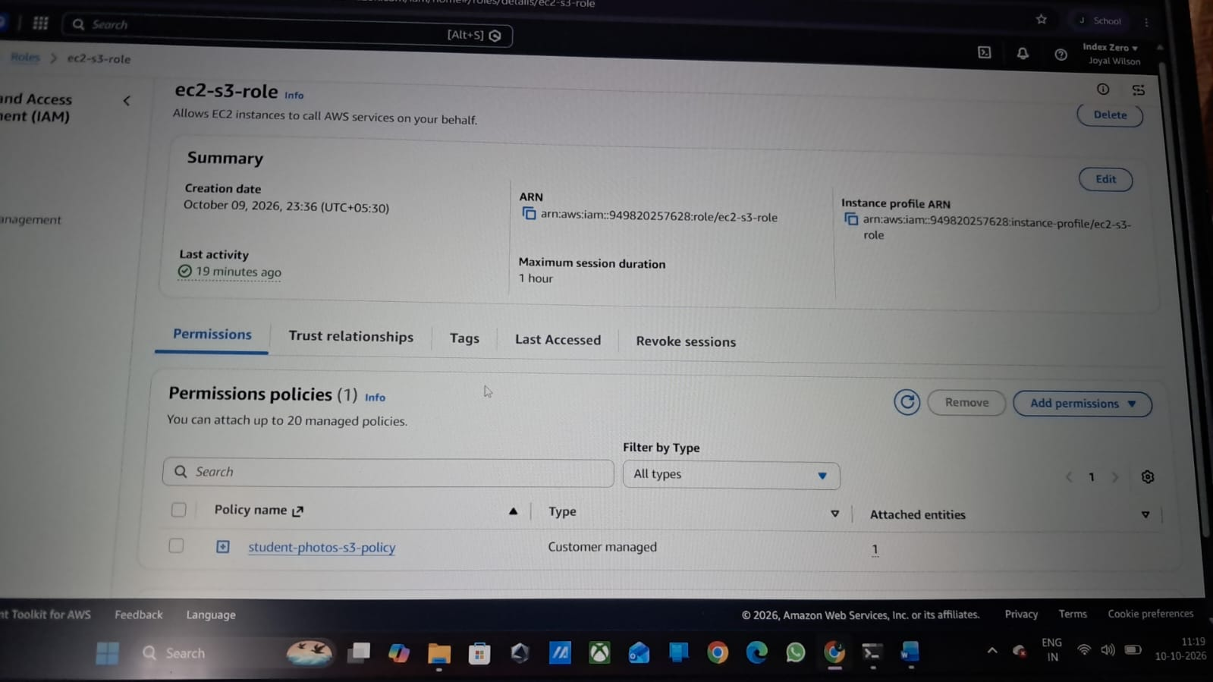
Caption / notes: _______________________________________________________________

5.4 S3 Bucket Configuration
Summarize the bucket settings and access-control decision.
[ Paste screenshot here: S3 bucket co5.3 S3 Bucket Configuration

Amazon Simple Storage Service (Amazon S3) was used to store student photos uploaded through the Flask web application.

### 1. Bucket Creation

An S3 bucket named student-photos-joyal-2026 was created in the AWS Sydney region (ap-southeast-2) to store student photo files.

### 2. Access Control

Block Public Access was enabled for the bucket to prevent public access to stored objects. The application accesses S3 through the IAM role attached to the EC2 instance.

### 3. File Upload

A student photo was uploaded to the S3 bucket. The Flask application uses the S3 object location to associate the uploaded photo with the student's registration record.

### 4. Encryption

Server-side encryption using Amazon S3-managed keys (SSE-S3) was enabled to protect stored objects at rest.

### 5. Security Benefits

- Prevents unrestricted public access to student photos.
- Uses IAM permissions to control access to S3 objects.
- Encrypts stored files at rest.
- Separates photo storage from the application server and database.nfiguration ] 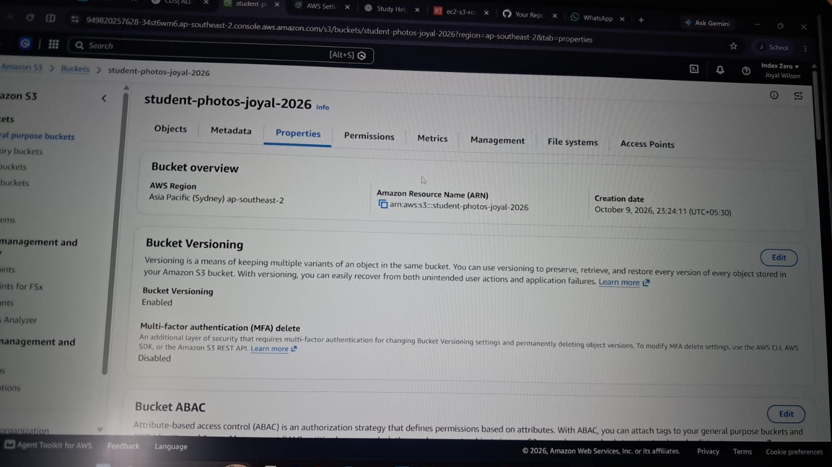
Caption / notes: _______________________________________________________________

5.5 RDS Database Setup
Summarize the DB subnet group, instance configuration, and schema creation.
[ Paste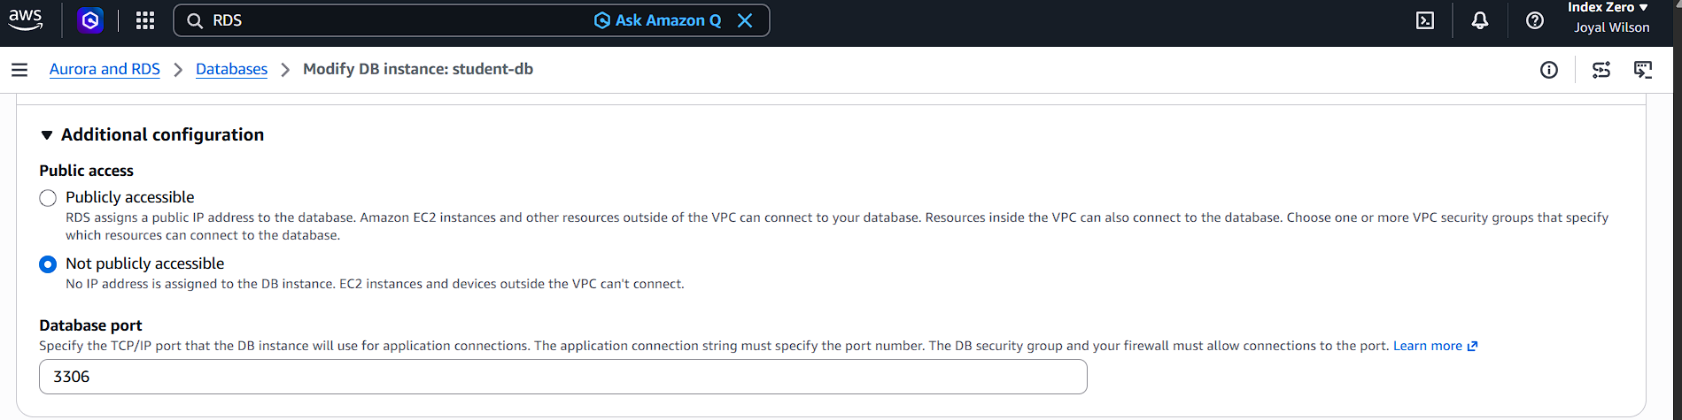 screenshot here: RDS configuration and schema ]
Caption / notes: _______________________________________________________________

5.6 EC2 & Application Deployment
Summarize how you deployed the Flask app — dependencies installed, environment variables used, and how the process is kept running (e.g., systemd + gunicorn).
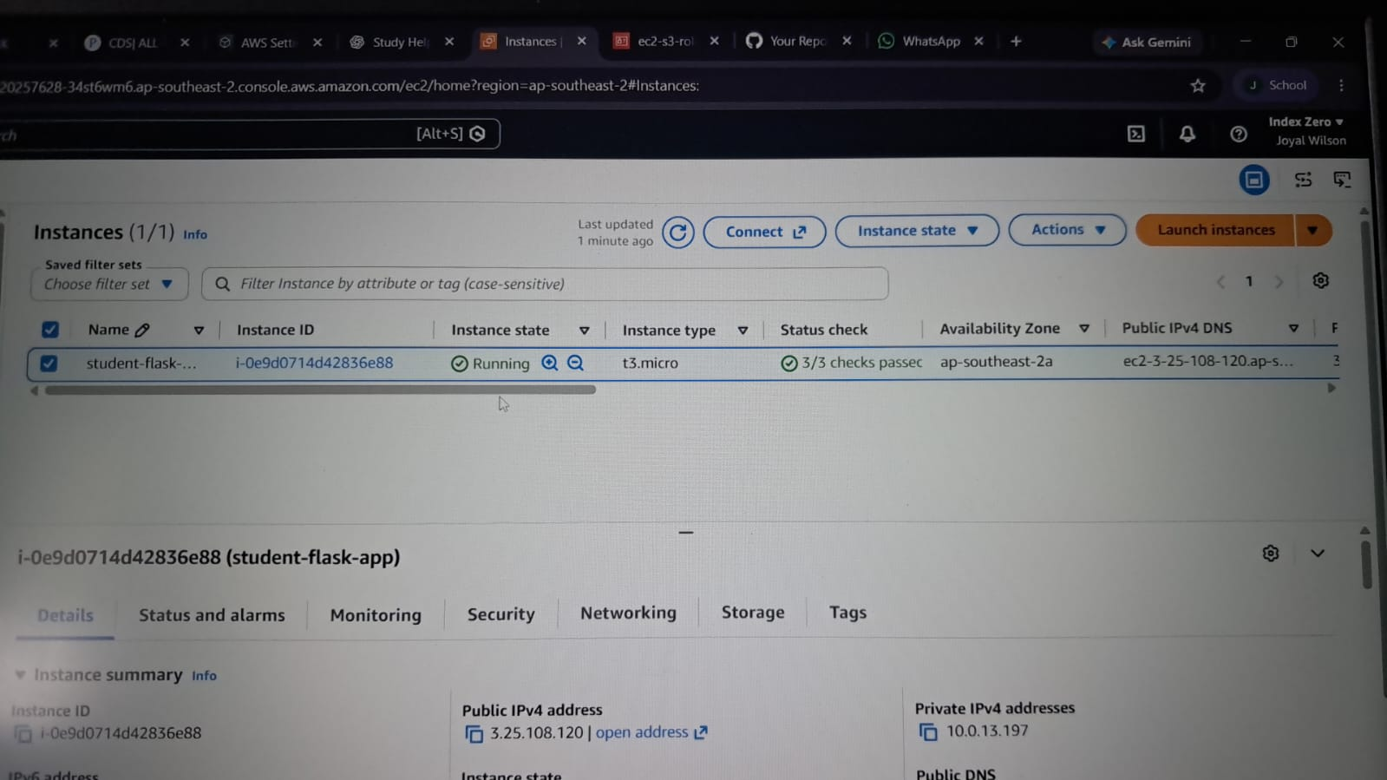

6. Testing & Validation
Test | Expected Result | Actual Result
Load registration form in browser | Form renders correctly | Student registration form loaded successfully
Submit form with a test photo | Success message shown | The registration form was submitted successfully
Check MySQL for new row | Row present with correct data | A new row successfully installed
Check S3 for uploaded photo | Object present in bucket | yes
Connect to RDS from outside the VPC | Connection times out / fails | Yes connected
Access bucket root URL anonymously | Access Denied | Bucket connents cannot accessed publicly.

Final deployed application URL: ____________________________________________
[ Paste screenshot here: Browser address bar + application loaded at yo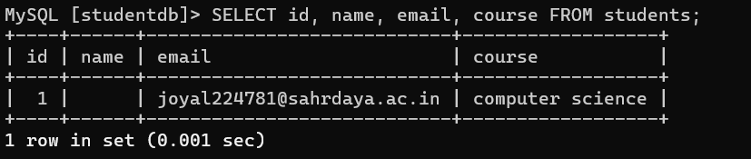ur final deployed URL ]
Caption / notes: _______________________________________________________________

7. Challenges Faced & Solutions
Describe at least two real problems you ran into and how you resolved them (e.g., a security group misconfiguration, an IAM permissions error, a subnet routing issue).

CHALLENGES FACED AND SOLUTIONS

During the deployment of the Flask student registration application on AWS, several configuration and integration challenges were encountered. The following solutions were applied to complete the project.

### 1. Database Connectivity

*Challenge:* Connecting the Flask application running on EC2 to the MySQL database hosted on Amazon RDS required correct database credentials and network configuration.

*Solution:* The database host, username, and password were configured using environment variables. The RDS security group was configured to allow MySQL traffic from the EC2 application security group.

### 2. S3 Bucket Access

*Challenge:* The application required permission to upload student photos to Amazon S3 while keeping the bucket private.

*Solution:* An IAM role named ec2-s3-role was attached to the EC2 instance. The associated policy allowed the required S3 object operations on the project bucket.

### 3. Network Configuration

*Challenge:* Correct communication between the browser, EC2 application, and RDS database required appropriate network and security group settings.

*Solution:* The VPC, subnets, route table, Internet Gateway, and security group rules were configured to support the required communication.

### 4. Application Deployment

*Challenge:* Running the Flask application on EC2 required installing Python dependencies and configuring the application environment.

*Solution:* A Python virtual environment was created, the required packages were installed, and the Flask application was configured and started on port 5000.

### 5. Verification of Stored Data

*Challenge:* It was necessary to confirm that student details and uploaded photos were stored correctly in the appropriate AWS services.

*Solution:* The MySQL students table was checked for the registration record, and the S3 bucket was checked to verify the uploaded photo.

### Conclusion

These challenges helped develop practical knowledge of AWS networking, IAM permissions, database connectivity, object storage, and web application deployment. The project demonstrated how multiple AWS services can be integrated to run a student registration application.

8. Conclusion
Summarize what you learned about secure cloud architecture, identity-based access, and network isolation.
CONCLUSION

The project successfully demonstrated the deployment of a Flask-based student registration web application on Amazon Web Services (AWS). Amazon EC2 was used to host the application, Amazon RDS for MySQL was used to store student registration details, and Amazon S3 was used to store student photos.

A Virtual Private Cloud (VPC), subnets, route tables, security groups, and an IAM role were configured to support network connectivity and control access to AWS resources. The application was tested by registering student details, verifying the database record, and checking the uploaded photo in the S3 bucket.

Through this project, practical knowledge was gained in cloud computing, web application deployment, database integration, object storage, and cloud security. Overall, the project demonstrated how AWS services can work together to provide a functional web application with appropriate access controls and organized data storage.

9. References
- Starter repository: https://github.com/gops601/pythoncodeAWS.git
- AWS Documentation — VPC, EC2, RDS, S3, IAM (add specific links you consulted)
Student Signature: __________________________ Date: __10-10-26____________

